Least Squares
Code:
import numpy as np
import pandas as pd
import matplotlib.pyplot as plt
from sklearn.datasets import load_diabetes
from sklearn.model_selection import train_test_split
from sklearn.linear_model import Ridge, Lasso
from sklearn.metrics import mean_squared_error, r2_score

raw_data = load_diabetes(as_frame=True)
df = raw_data.frame
df_sample = df.sample(n=300, random_state=42).sort_values(by='bmi')

X = df_sample[['bmi']].values
y = df_sample['target'].values.reshape(-1,1)

X_train, X_test, y_train, y_test = train_test_split(X, y, test_size=0.2, random_state=42)

print(f"Dataset loaded. Training shapes: X = {X_train.shape}, y= {y_train.shape}")
df_sample[['bmi', 'target']].head()

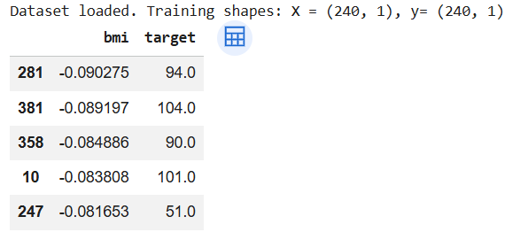

plt.figure(figsize=(10,6))
plt.scatter(X_train, y_train, color='blue', label='Training Data')
plt.scatter(X_test, y_test, color='red', label='Testing Data')
plt.xlabel('BMI')
plt.ylabel('Disease Progression')
plt.title('Training and Testing Data')
plt.legend()
plt.grid(True, linestyle='--', alpha=0.5)
plt.show()
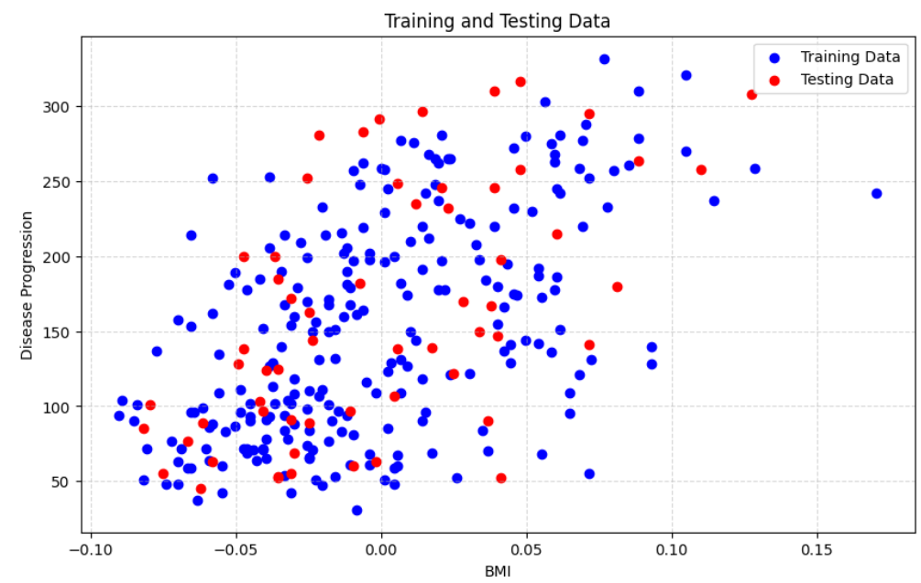
X_train_bias = np.c_[np.ones((X_train.shape[0], 1)), X_train]
X_test_bias = np.c_[np.ones((X_test.shape[0], 1)), X_test]

theta_best = np.linalg.inv(X_train_bias.T.dot(X_train_bias)).dot(X_train_bias.T).dot(y_train)

intercept, slope = theta_best[0][0], theta_best[1][0]

print(f"Calculate Intercept (w0) : {intercept:.4f}")
print(f"Calculate Slope (w1) : {slope:.4f}")

y_pred_ols = X_test_bias.dot(theta_best)

